Course Code: CS301 (Data Structures)
Assignment No. 5 Solution:
Question No. 1
The array representation of the given MAX HEAP is as follows,
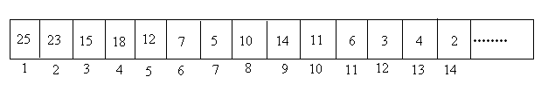
Question No. 2
The complete Binary tree for the given array would be as follows,
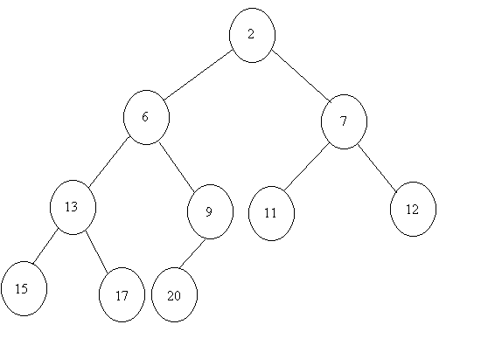
As the given tree is not only a complete binary tree but also obey the heap property, so it is also a MIN HEAP.

