 | Assignment No. 03  Semester: Spring 2012  CS401: Computer Architecture and Assembly Language Programming |  | Total Marks: 20  Due Date:11 june,2012
Instructions
Please read the following instructions carefully before submitting assignment:
It should be clear that your assignment will not get any credit if:

- The assignment is submitted after due date.
- The submitted assignment does not open or file is corrupt.
- Solution is copied from any other source.

Note: You have to upload only .doc file. Assignment in any other format (extension) will not be accepted.

Objective
The objective of this assignment is to enhance your knowledge about;

- Software Interrupts
- Real Time Interrupts and Hardware Interfacing

Assignment
Question:

DC motor (fig 1) is operated through two terminals, whenever the potential difference is created (through batteries, cells etc) across these terminals the motor starts its motion.

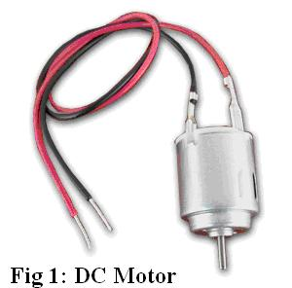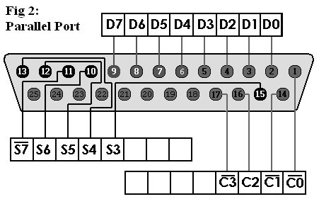

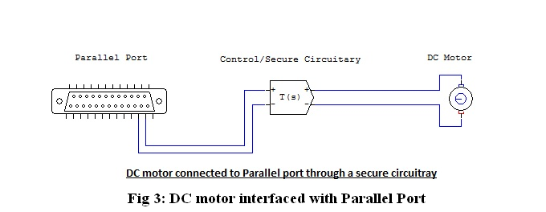

Suppose we have connected a DC motor to our system’s parallel port through a secure circuitry (fig 3).

We wish to operate the DC motor through our parallel port (fig 2) using some input through our keyboard. Like “F” key for running motor in “Forward Direction”, “R” for “Reverse Direction”, “S” for “Stop” and “E” for “Exit from code”.

We have suggested that we will use parallel port’s Pin 2 and Pin 3 (the last 2 pins of parallel port’s data check fig 2 and table 1).

Pin 2 | Pin 3 | Outcome
0 | 0 | Stop
0 | 1 | Forward
1 | 0 | Reverse
1 | 1 | No Operation
Table 1

You have to write a code in assembly language that take an input character from keyboard (S, F, R and E) and on the basis of these characters transmit the code (with respect to the truth table) to the parallel port to operate that connected DC motor.

NOTE: your code only use ASCII code for Capital letters F, R, S and E as an input from the keyboard and will transmit the specific data to the parallel port. Through this program, we are interested in communicating with a DC motor through parallel port.

SOLUTION:

ORG 0100H

XOR AX, AX ; clearing AX
XOR DX, DX ; clearing DX

MAIN:
MOV AH, 1H ; keyboard input
INT 21H ; read character into AL

CMP AL, 53H ; compare AL with “S”
JE S ; jump to “Stop routine”

CMP AL, 46H ; compare AL with “F”
JE F ; jump to “Forward routine”

CMP AL, 52H ; compare AL with “R”
JE R ; jump to “Reverse routine”

CMP AL, 45H ; compare AL with “E”
JE END ; jump to “Exit routine”

JMP MAIN ; jump to main program

S: MOV AL, 00H ; setting AL to STOP mode
MOV DX, 0x378
OUT DX, AL ; writing data to Parallel port
JMP MAIN

F: MOV AL, 01H ; moving motor in forward direction
MOV DX, 0x378
OUT DX, AL ; writing data to Parallel port
JMP MAIN

R: MOV AL, 02H ; moving motor in reverse direction
MOV DX, 0x378
OUT DX, AL ; writing data to Parallel port
JMP MAIN

END: MOV AX, 4C00H
INT 21H

